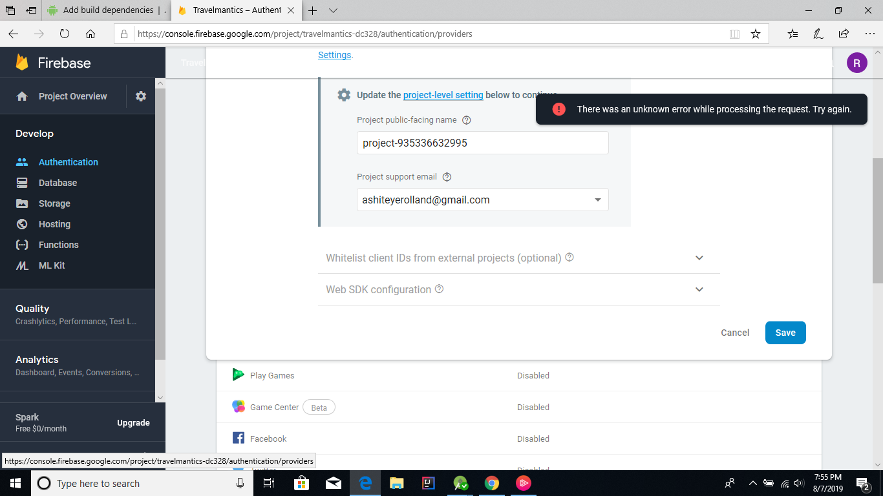

This error got me stuck when trying to authenticate users with gmail. Tried several times and it did not work hence could not continue with the work hence I did not manage to finish. I did not get any solution to the error.